**Key points the President Jacob Zuma raised during the State of the Nation Address (SONA)**

In the State of the Nation address on 11 February 2016, President Jacob Zuma highlighted the following areas government needed to work on in 2016:

1) The local government elections this year. President Zuma urged the youth to register to vote. Measures to improve performance included visits to municipalities, spot checks of supply chain processes, implementing recommendations of forensic reports, and increased interventions to help struggling municipalities.

2) President Zuma announced the establishment of a state-owned pharmaceutical company which would supply the department of health with antiretroviral medicines in the 2016/17 financial year. Health Minister Aaron Motsoaledi would soon announce a major HIV prevention campaign, aimed at the youth.

3) To date, around 120 000 land claims had been received since government reopened the process

[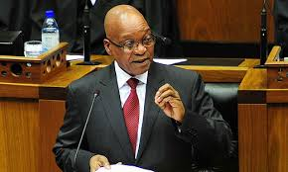](https://www.google.kz/imgres?imgurl=http://drum.co.za/wp-content/uploads/2015/02/140214ZumaSona-jpg.jpg&imgrefurl=http://drum.co.za/news/sona2015-zuma-speech-uninspiring/&h=311&w=520&tbnid=l67qkYSeqQdRpM:&docid=wMxAjJ917iTwEM&ei=tazKVqj1N4K3a-nwrrAI&tbm=isch)

The President of the Republic of South Africa, H.E. Mr. Jacob G. Zuma

for those who had missed the 1998 deadline. A draft bill capping land ownership at 12 000 hectares and prohibiting foreigners from owning land, allowing long-term leases instead, would be presented to Parliament later this year.

4) Fifty-seven police officers had been killed since the start of the 2015/16 financial year. "We urge the police to defend themselves when attacked, within the confines of the law. "Efforts were being made to improve under-performing police stations.

5) Five provinces had been seriously affected by the drought and government was providing relief to affected communities. He thanked civil society initiatives such as Operation Hydrate for their help.

6) He attributed the country's economic woes to the economic slump emerging market economies elsewhere in the world were facing.

7) The country would roll out a nuclear programme at a pace South Africa could afford.

8) Government would introduce cost-cutting measures to curb wasteful expenditure. Any government official wanting to go on an overseas trip would have to "motivate strongly" and explain how it would benefit the country.

9) Parliament had been told to look at having two capitals, Pretoria as the administrative, and Cape Town as the legislative one, as this was too big a cost to maintain.

10) An improved migration policy would make it easier for companies to import scarce skills.

**Budget in a nutshell**

[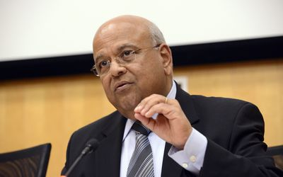](http://www.google.kz/url?sa=i&rct=j&q=&esrc=s&source=images&cd=&cad=rja&uact=8&ved=0ahUKEwjZp-L945TLAhXBPxQKHYCDDFcQjRwIBw&url=http://www.bdlive.co.za/economy/2014/02/23/pravin-gordhans-pounding-headache&psig=AFQjCNEtvMZQ_3eaP40HwNyDKWB62swXdw&ust=1456553793243934)

**Finance Minister of the Republic of South Africa, Mr. Pravin Gordhan**

Cape Town - Finance Minister Pravin Gordhan’s first comeback National Budget tabled on 24 February 2016 in Parliament was relatively calm after all the expectations of tax hikes and spending cuts amid tough economic times.

He stressed the need to reaffirm government’s commitment to close the gap between spending and revenue,

implementing a plan for stronger economic growth and cooperation be-

tween government and the business sector. That should keep the rating agencies that want to downgrade SA’s debt position to junk status temporarily at bay.

Personal income tax rates were not increased, although about R18bn more will be collected in 2016/17. This will mostly be through yet another big increase of 30 cents per litre in the fuel levy as well as increases in capital gains tax, property transfer tax and an increase of about 7% in the usual sin taxes (alcohol and tobacco) A new tyre levy and a tax on sugar intake (only next year on sweetened beverages) will also be introduced.

The expenditure ceiling was also cut by R25bn over the next three years to bring the budget deficit down to 2.4% of gross domestic product by 2018/19, and to stabilise debt as percentage of GDP around 45% of GDP.

The public sector wage bill will be cut, but provision for contingencies like drought relief and additional spending has been made and increases in expenditure on for example higher education and small business development continue. Gordhan stressed that the government would not burden South Africans with “austerity measures”, and that social grants will also be raised.

Government has responded to new spending needs without compromising expenditure limits. An amount of R31.8bn has been reprioritised over the medium-term expenditure framework period to support higher education, the New Development Bank and other priorities.

_____________________________________________________________________________________________________________

**SA Embassy meets with ISTC**

The South African Embassy in Astana met with the International Science and Technology Centre (ISTC) on 22 February 2016. Ambassador S. M. Soni, Mr. Theo Malherbe and Ms. Jamilya Akmurzayeva held the meeting to discuss cooperation possibilities with Executive Director Mr. David Cleave, Deputy Executive Director Aidyn

Turebayev and Senior Project Manager (European Union) Dr. Graeme Frith of the ISTC. The meeting was also attended by the Minister Plenipotentiary, Head of the Political, Press and Information Section of the Delegation of the European Union to the Republic of Kazakhstan, Mr. Kamen Velichkov.

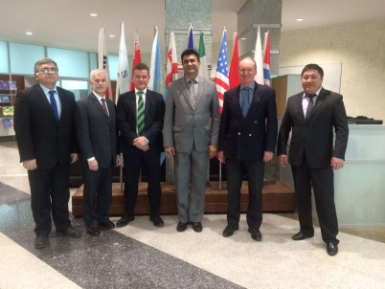

**A Kazakh delegation headed by Deputy Minister of Foreign Affairs Yerzhan Ashikbayev took part as an observer country** in the 26th Ordinary Session of the Assembly of Heads of State and Government of the African Union in the capital of Ethiopia Addis Ababa on Jan. 27-31, 2016.

This event was dedicated to the issues of sustainable development in Africa in terms of realization of the goals of the African Union Agenda 2063. The Summit participants discussed the issues of economic and investment cooperation in the African continent, provision of regional security, promotion of human rights and migration policy. Particular attention was paid to the aspects of gender equality and to the outcomes of work in 2015 regarding women empowerment issues.

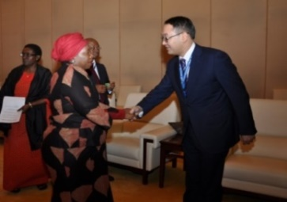

The Chairperson of the African Union, H.E. Dr. Dlamini-Nkosazana Zuma and the Deputy Minister for Foreign Affairs, H.E. Mr. Yerzhan Ashikbayev

During the Summit, the Kazakh side jointly with UNDP organized a Special Event dedicated to the strengthening of South – South Cooperation for implementation of Sustainable Development Goals (SDG) in Africa. Ministers of foreign affairs of African countries and heads of international organizations were among the participants of the event.

<http://www.mfa.gov.kz/index.php/en/last-news/5776-kazakh-delegation-takes-part-in-26th-ordinary-session-of-assembly-of-heads-of-state-and-government-of-african-union>

**_____________________________________________________________________________________________________________**

**A lecture at the Nazarbayev Univer-**

**sity on 08 February 2016**

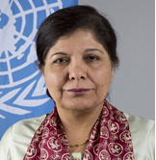

**The Under-Secretary-General of the UN and Executive Secretary of ESCAP Dr. Shamshad Akhtar.**

On 08 February 2016 Ambassador S. M. Soni, Mr. Malherbe and Ms. Jamilya Akmurzayeva attended a lecture “Asia Pacific: Recent Economic

and Trade Performance with Focus on North and Central Asia” at the Nazarbayev University delivered by the Under-Secretary-General of the UN and Executive Secretary of ESCAP Dr. Shamshad Akhtar.

The ESCAP (United Nations Economic & Social Commission for Asia and the Pacific’s forecast for the regions is:

- A “new normal” of slower economic growth continues amidst weak global trade and China’s slow growth; AP economies will need to look more towards domestic and regional demand.

- Fiscal policy can tackle cyclical and long-term challenges, and relieve pressure on monetary policy, provided tax revenues are strengthened.

- Economies in NCA need to diversify and reduce dependence on commodities.

- Rapid increases in private debt call for vigilance, especially as financing costs are likely to increase in the region.

- Productivity growth should be accelerated and its benefits adequately shared with the labour force.

- With the adoption of 2030 Agenda for Sustainable Development, it is not just about economic growth anymore ---- we live in the era of sustainable development.

**2016 African Leaders Malaria Award**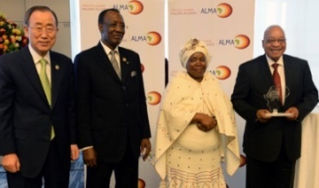

Congratulations South Africa on being awarded the 2016 African Leaders Malaria Award (ALMA) for achieving the Millennium Development Goals target for fighting Malaria at the AU Summit, Addis Ababa. Hats off to our health professionals!

____________________________________________________________________________________________________________

**Presentation by the Kyrgyz Ambassador in KAZGUU**

The South African Embassy in Kazakhstan in conjunction with the Embassy of Norway in Kazakhstan and the KAZGUU University, held a roundtable discussion addressed by the Kyrgyz Ambassador to Kazakhstan H.E. Mr. Esengul Omuraliev on 29 January 2016 at the KAZGUU University within the Academic Diplomatic Club. During his speech, Ambassador Omuraliev spoke about the main developments in 2015 in Kyrgyzstan's domestic politics, economic develop ent and plans for 2016. He mentioned positive

changes in the country, including in politics, military and judicial reforms and the fight against corruption.

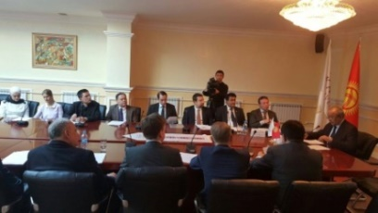

The Kyrgyz Ambassador pointed out the 2015 parliamentary elections,

strengthening of the energy independence of the country, construction of new strategic roads and maintaining the positive trend of economic growth.

He also drew attention to the new program of the government and its priorities. As for the foreign policy activities planned for 2016, Ambassador Omuraliev particularly named the Kyrgyzstan's presidency of the CIS, the Cooperation Council of Turkic Speaking States and the 2nd World Nomad Games.The roundtable was attended by Heads of Diplomatic Missions resident in Astana and accredited to the Kyrgyz Republic.

**Farewell event in honour of the Japan Ambassador and the Ambassador of the UAE at the KazGUU**

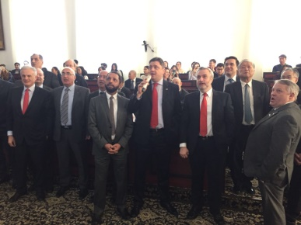

Ambassadors are singing karaoke

On 15 February 2016 the South African Embassy to the Republic of Kazakhstan and the Embassy of the Kingdom of Norway together with the KazGUU Academic Diplomatic Club

hosted a farewell event in honour of the outgoing Ambassador of Japan H.E. Masayoshi Kamohara and his spouse and the Ambassador of the United Arab Emirates H.E. Suhail Matar within the KazGUU Academic Diplomatic Club. The event was attended by more than 40 Heads of Diplomatic Missions and their spouses, students of the KazGUU University and their teachers, as well as the spouse of the Kazakh Deputy Minister for Foreign Affairs Mrs. Zhanar Mussinova.

The South African Ambassador H.E. Mr. Shirish M. Soni was a moderator of the event being a Co-chair of the KazGUU Academic Diplomatic Club.

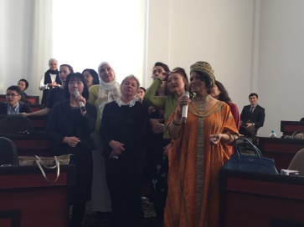

Spouses of Ambassadors

The tradition of hosting farewell events within the Academic Diplomatic Club was initiated by the South African Ambassador Mr. Shirish Soni as a courtesy to the outgoing Heads of other Diplomatic Missions accredited to Kazakhstan, as well as to create a platform for a dialogue between representatives of the Diplomatic Corps and students.

_____________________________________________________________________________________________________________

**Tourism INDABA**

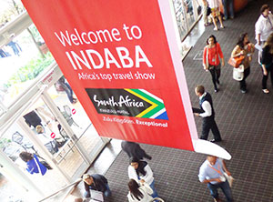

INDABA is one of the largest tourism marketing events on the African calendar and one of the top three ‘must visit’ events of its kind on the global calendar which will be showcased this year from 7 to 9 May.

It showcases the widest variety of Southern Africa's best tourism products and attracts international buyers and media from across the world. INDABA is owned by South African Tourism and organised by Pure Grit Project and Exhibitions Management (Pty) Ltd.

INDABA has won the awards for Africa’s best travel and tourism show. This award was presented by the Association of World Travel Awards.

**For more information please see:** [www.indaba-southafrica.co.za](http://www.indaba-southafrica.co.za)

South African Tourism: [www.southafrica.net](http://www.southafrica.net)

**WELCOME TO THE 35TH IGC** South Africa will be hosting the 35th ‘World Congress of Geosciences’ in 2016, the prestigious International Geological Congress (IGC), which is undoubtedly the most important activity of the International Union of Geological Sciences (IUGS). The South African event will take place at the Cape Town International Convention Centre from 27 August to 4 September 2016.

Only two of these prestigious conferences have been held in Africa before. The first was hosted by South Africa in Pretoria in 1929 and was instrumental in advancing the study of geology and the earth sciences in South Africa and on the continent. The other IGC was held on the continent of Africa in Algeria in 1952. The event will be organised by a Local Organising Committee (LOC) with the help of several subcommittees that



have been mandated to organise different aspects of the event:

The core topics for the Congress are Geoscience for Society, Fundamental Geoscience and Geoscience in the Economy. A total of 49 themes covering all disciplines in the geosciences will form the basis of the technical programme.

The 35th IGC will be marketed and organised as an African rather than a South African event. The organisers therefore plan to involve other African countries as much as possible, mainly by sponsoring the participation of less privileged African students and by field excursions to the rest of Africa.

**For more information please see:** [www.35igc.org](http://www.35igc.org)

_____________________________________________________________________________________________________________

**Celebration of Nauryz in Pretoria, SA**

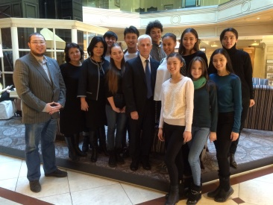

Mr. D. Sharipov, the Sponsor, the Ballet group with teachers and The Counsellor of the South African Embassy in Astana

The Counsellor of the South African Embassy, Mr. Theo Malherbe and Ms. Jamilya Akmurzayeva, the Trade and Info Assistant met with Mr. Daniyar Sharipov of “Ulken Kus” company while having a working trip to Almaty on 16 February 2016.

Mr. Sharipov is assisting the ballet group of the Almaty Choreography School visiting South Africa in March 2016 to perform during the celebration of Nauryz in South Africa. The ballet group will also participate in master classes, training, etc.

The Embassy of the Republic of Kazakhstan in Pretoria is organising this event.

Officials of the Department of International Relations and Cooperation of South Africa will also be invited.